## **Dictionary ::**

python **dictionary** is an unordered collection of items while other compound data types have only value as **an element a dictionary has a key value pair dictionaries**

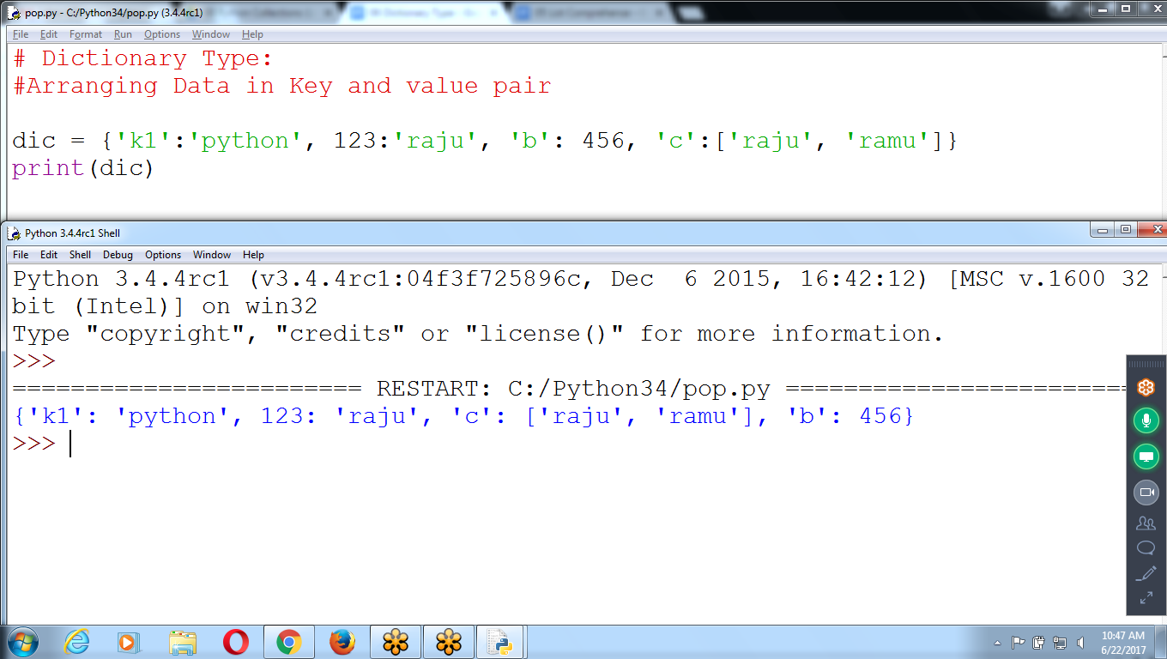

**# Dictionary Type:**

**#Arranging Data in Key and value pair**

**dic = {'k1':'python', 123:'raju', 'b': 456, 'c':['raju', 'ramu']}**

**print(dic)**

**To Print Only Keys, Items, Values**

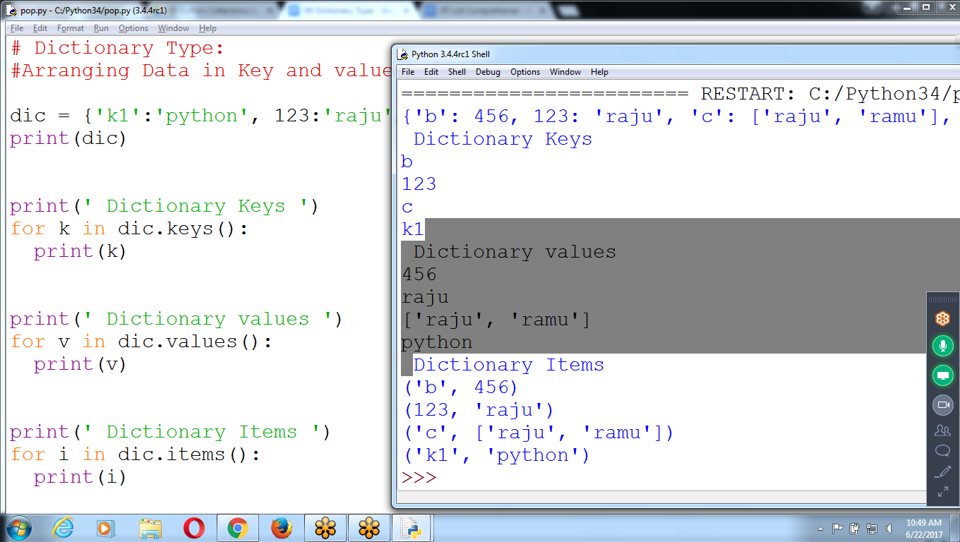

**# Dictionary Type:**

**#Arranging Data in Key and value pair**

**dic = {'k1':'python', 123:'raju', 'b': 456, 'c':['raju', 'ramu']}**

**print(dic)**

**print(' Dictionary Keys ')**

**for k in dic.keys():**

**print(k)**

**print(' Dictionary values ')**

**for v in dic.values():**

**print(v)**

**print(' Dictionary Items ')**

**for i in dic.items():**

**print(i)**

**>>> ls=['raju', 'ramu', 'siva']**

**>>> ls**

**['raju', 'ramu', 'siva']**

**>>> dic = {'l1':'raju', 'l2':'siva', 123:456, 567:'sivaji', 123:['raju', 'rani']}**

**>>> dic**

**{'l2': 'siva', 123: ['raju', 'rani'], 'l1': 'raju', 567: 'sivaji'}**

**>>> dic.keys()**

**dict_keys(['l2', 123, 'l1', 567])**

**>>> dic.values()**

**dict_values(['siva', ['raju', 'rani'], 'raju', 'sivaji'])**

**>>> dic.items()**

**dict_items([('l2', 'siva'), (123, ['raju', 'rani']), ('l1', 'raju'), (567, 'sivaji')])**

**>>>**

**>>> for v in dic.values():**

**print(v)**

**siva**

**['raju', 'rani']**

**raju**

**Sivaji**

**>>> for k in dic.keys():**

**print(k)**

**l2**

**123**

**l1**

**567**

**>>>**

**Key can be Integer, Float, STring**

**Values can be Integer, float, string or List type**

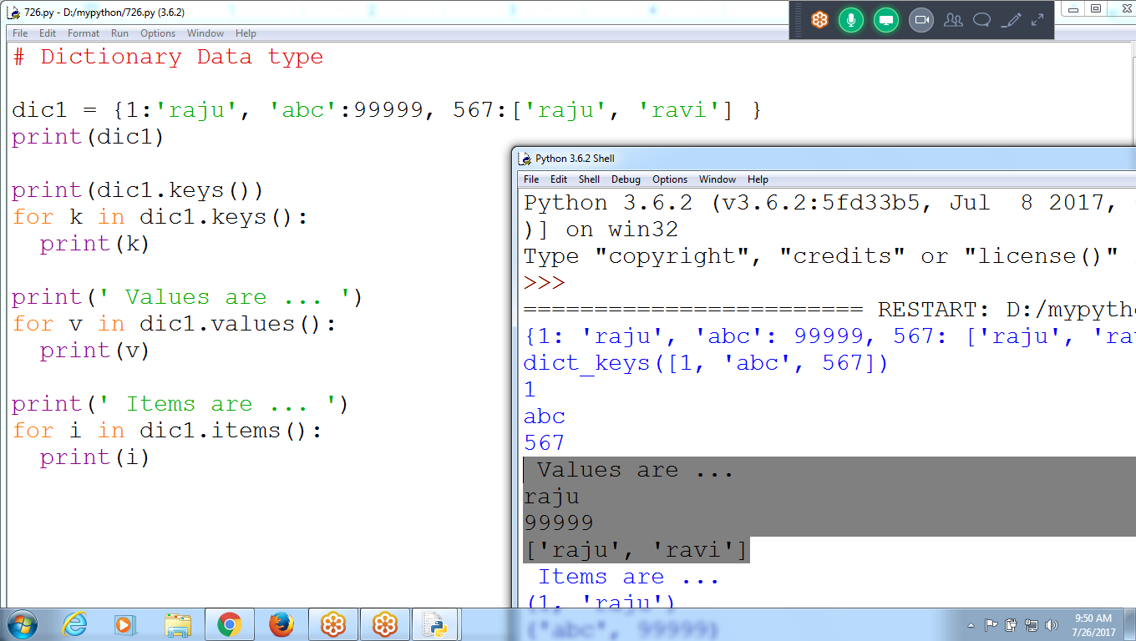

**# Dictionary Data type**

**dic1 = {1:'raju', 'abc':99999, 567:['raju', 'ravi'] }**

**print(dic1)**

**print(dic1.keys())**

**for k in dic1.keys():**

**print(k)**

**print(' Values are ... ')**

**for v in dic1.values():**

**print(v)**

**print(' Items are ... ')**

**for i in dic1.items():**

**print(i)**

**How to Assign and Update values to dictionary Data type**

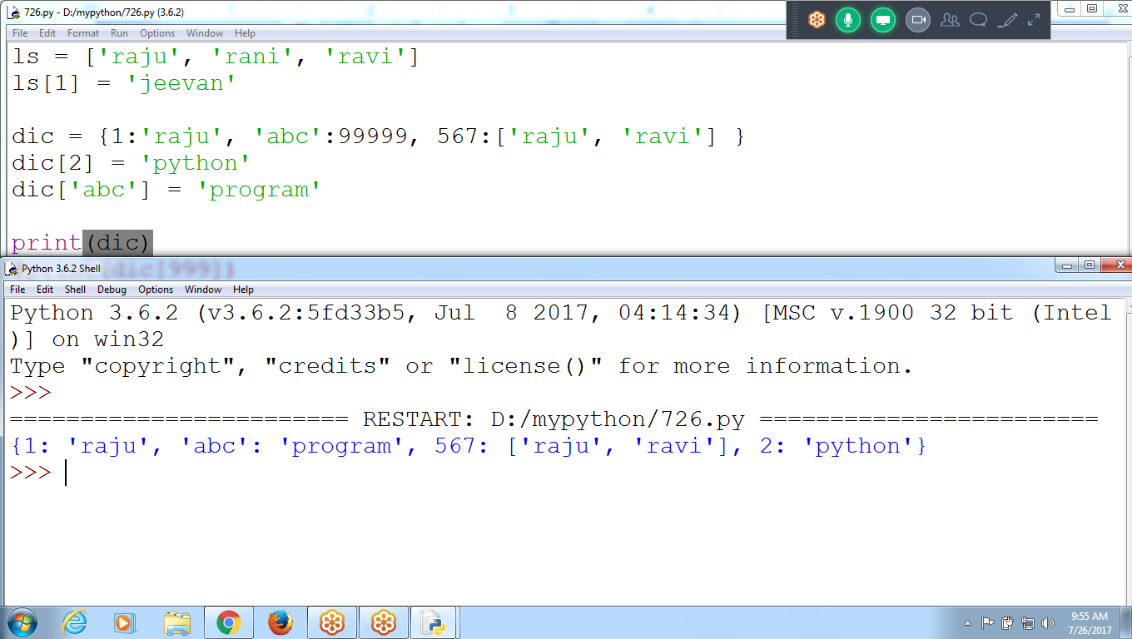

**ls = ['raju', 'rani', 'ravi']**

**ls[1] = 'jeevan'**

**dic = {1:'raju', 'abc':99999, 567:['raju', 'ravi'] }**

**dic[2] = 'python' # not existing, creates new key**

**dic['abc'] = 'program' # Updating the key**

**print(dic)**

**#print(dic[999])**

**IF key exist, replace with new value otherwise creates new KEY**

**>>> dic = {'lang1':'python', 123:'raju', 3.25:'Siva', '12':456}**

**>>> dic**

**{3.25: 'Siva', 123: 'raju', '12': 456, 'lang1': 'python'}**

**>>> dic['lang1'] = 'anand'**

**>>> dic**

**{3.25: 'Siva', 123: 'raju', '12': 456, 'lang1': 'anand'}**

**>>> dic['lang2'] = 'python shell'**

**>>> dic**

**{3.25: 'Siva', 'lang2': 'python shell', 123: 'raju', '12': 456, 'lang1': 'anand'}**

**>>>**

**dic[123] = ['raju', 'ravi', 999] # Assigning List to Dictionary item**

**print(dic)**

**dic[3.25] = ('apple', 'grapes') # Assigning Tuple to Dictionary Item**

**print(dic)**

**print(dic[3.25]) # Printing value at dictionary key 3.25**

**get() method**

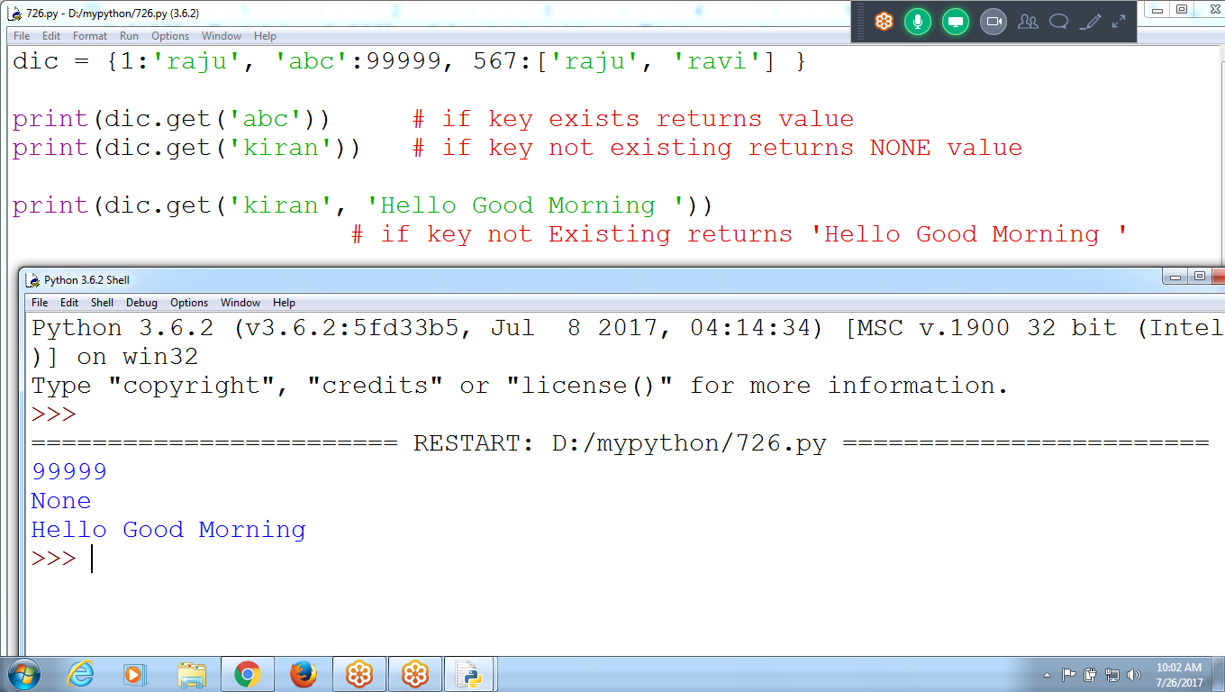

**dic = {1:'raju', 'abc':99999, 567:['raju', 'ravi'] }**

**print(dic.get('abc')) # if key exists returns value**

**print(dic.get('kiran')) # if key not existing returns NONE value**

**print(dic.get('kiran', 'Hello Good Morning '))**

**# if key not Existing returns 'Hello Good Morning '**

**How to Insert, Remove and Update**

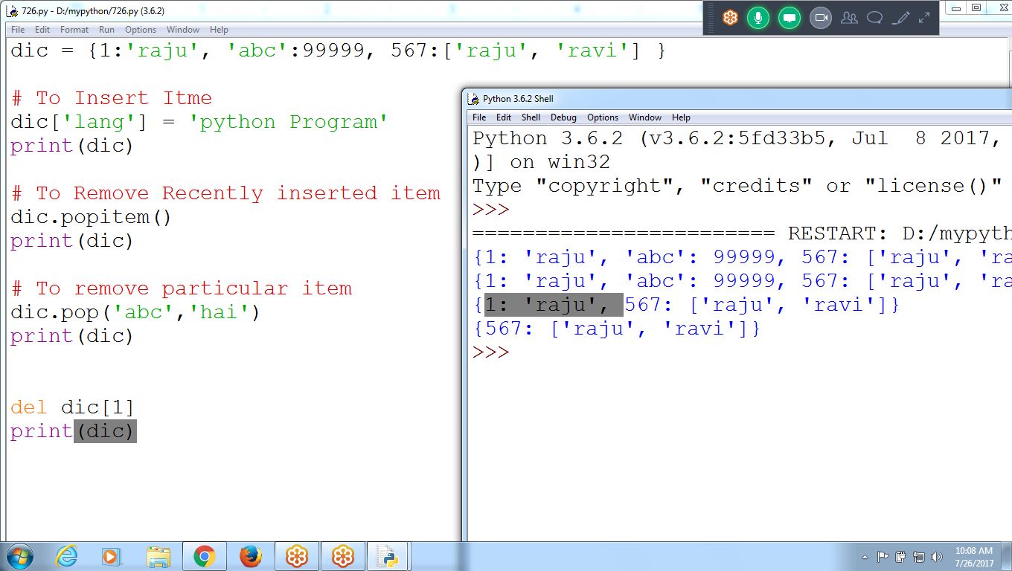

**dic = {1:'raju', 'abc':99999, 567:['raju', 'ravi'] }**

**# To Insert Item**

**dic['lang'] = 'python Program'**

**print(dic)**

**# To Remove Recently inserted item**

**dic.popitem()**

**print(dic)**

**# To remove particular item**

**dic.pop('abc','hai')**

**print(dic)**

**del dic[1]**

**print(dic)**

**# Don’t append(), since append takes one argument**

**# to insert in dictionary requires two parameter, key and value**

**Checking Key existing or not in dictionary**

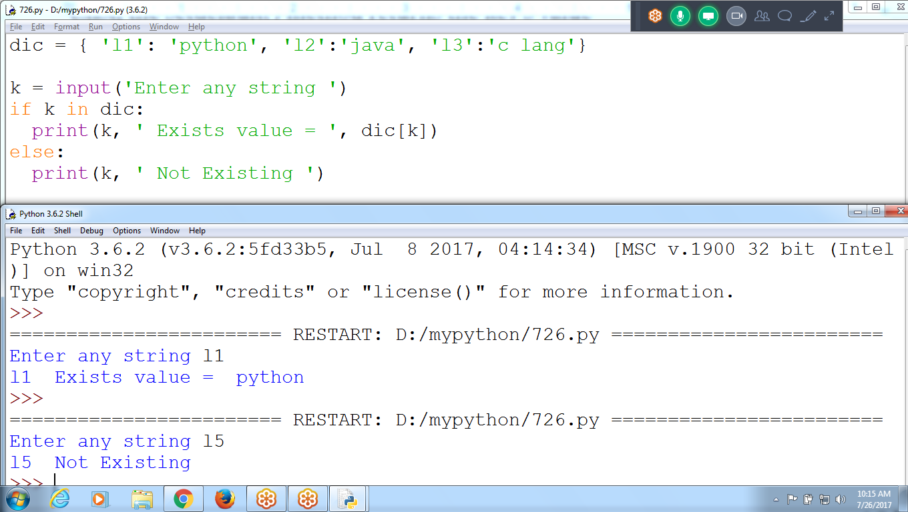

**dic = { 'l1': 'python', 'l2':'java', 'l3':'c lang'}**

**k = input('Enter any string ')**

**if k in dic:**

**print(k, ' Exists value = ', dic[k])**

**else:**

**print(k, ' Not Existing ')**

**How to Assign and Update keys in dictionary**

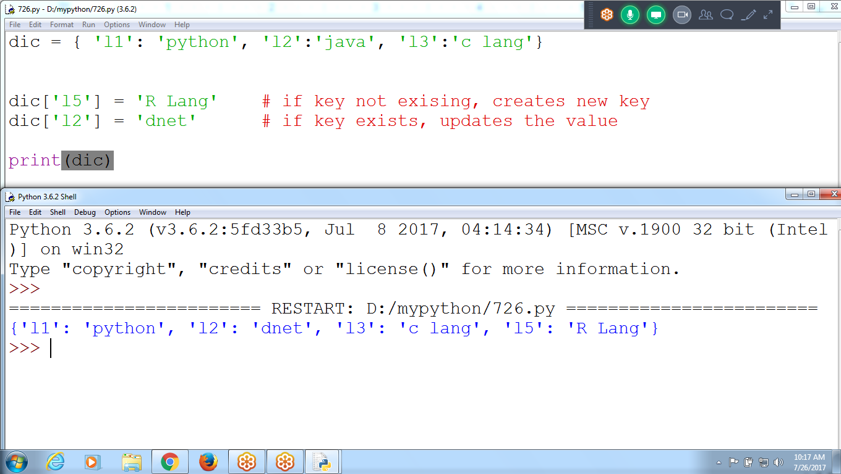

**dic = { 'l1': 'python', 'l2':'java', 'l3':'c lang'}**

**dic['l5'] = 'R Lang' # if key not existing, creates new key**

**dic['l2'] = 'dnet' # if key exists, updates the value**

**print(dic)**

## **The setdefault() Method**

The first argument passed to the method is the key to check for, and the second argument is the **value to set at** that key if the key does not exist. If the key does exist, the setdefault() method returns the key’s value

**dic.setdefault('l8', 'django')**

**# NOT Existing creating new key and assigning new value**

**dic.setdefault('l2', 'c++') #if exists, no new value assignment**

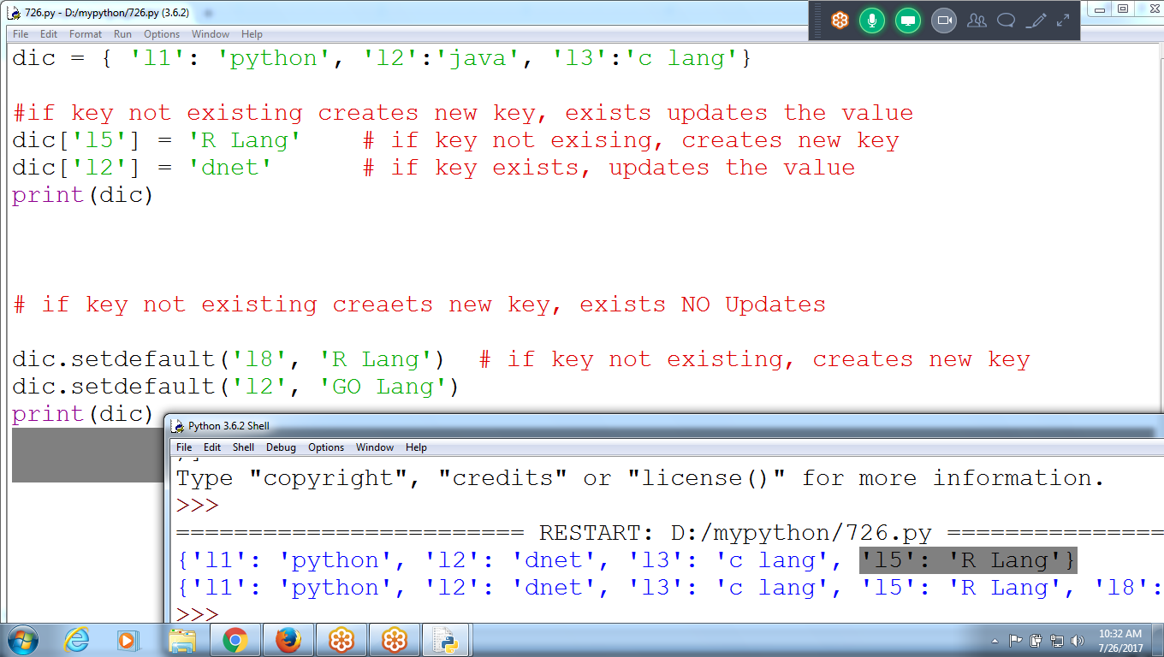

dic = { 'l1': 'python', 'l2':'java', 'l3':'c lang'}

#if key not existing creates new key, exists updates the value

dic['l5'] = 'R Lang' # if key not exising, creates new key

dic['l2'] = 'dnet' # if key exists, updates the value

print(dic)

# if key not existing creaets new key, exists NO Updates

dic.setdefault('l8', 'R Lang') # if key not existing, creates new key

dic.setdefault('l2', 'GO Lang')

print(dic)

****************************************************************************************************************************************************************************************************************************************